**Microprocessor and Computer Architecture Laboratory**

**UE19CS256**

**4th Semester, Academic Year 2020-21**

|  |  |  |
| --- | --- | --- |
| **Name**:  Atul Anurag | **SRN**:  PES2UG19CS075 | **Section**:  B |

**Date**: 03-02-2021

**WEEK#2**

Program Number: 1

Based on the value of the number in R0, Write an ALP to store 1 in R1 if R0 is zero, Store 2 in R1 if R0 is positive, Store 3 in R1 if R0 is negative.

1. ARM Assembly Code for each program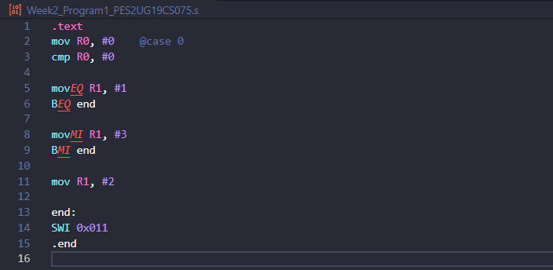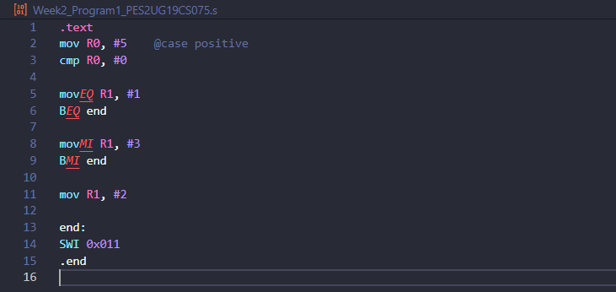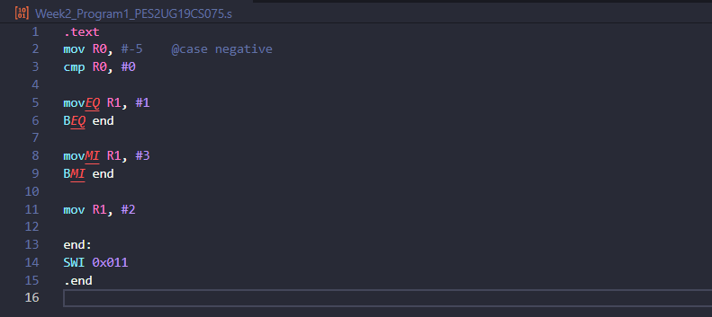
2. Output Screen Shot

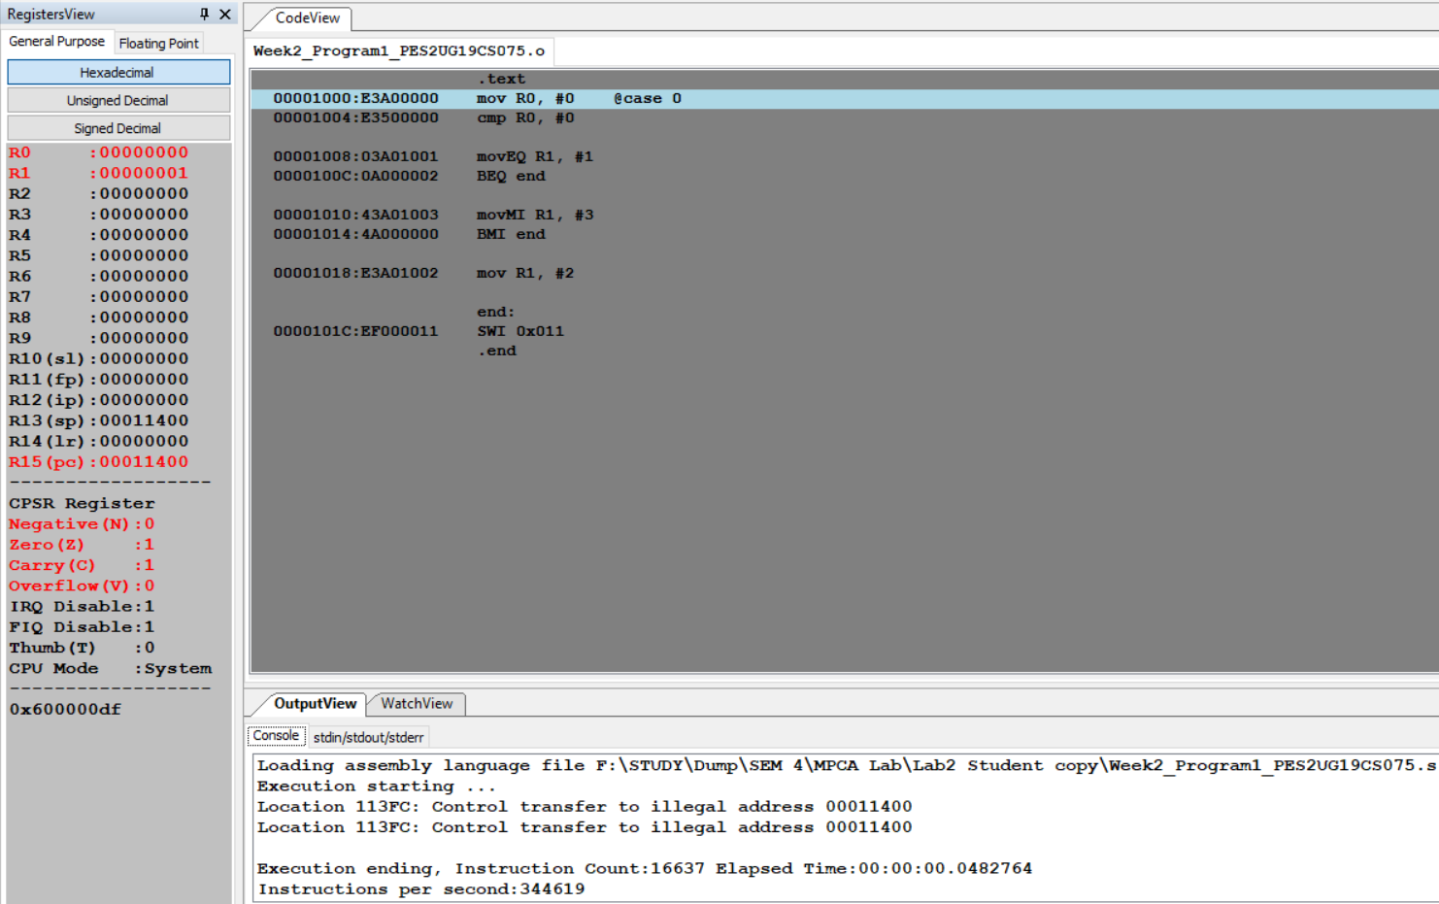

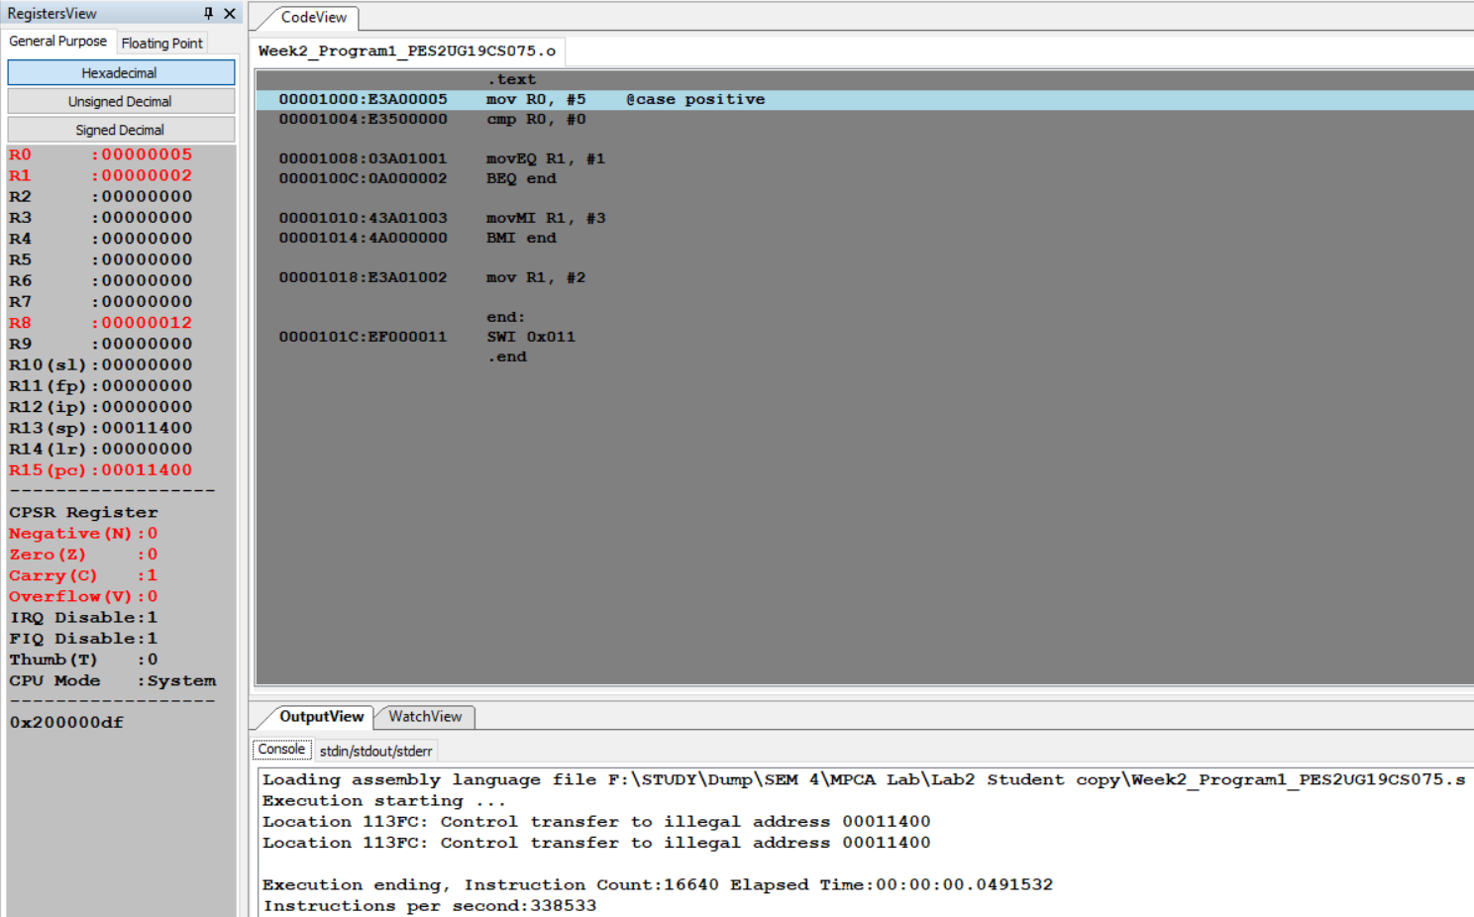

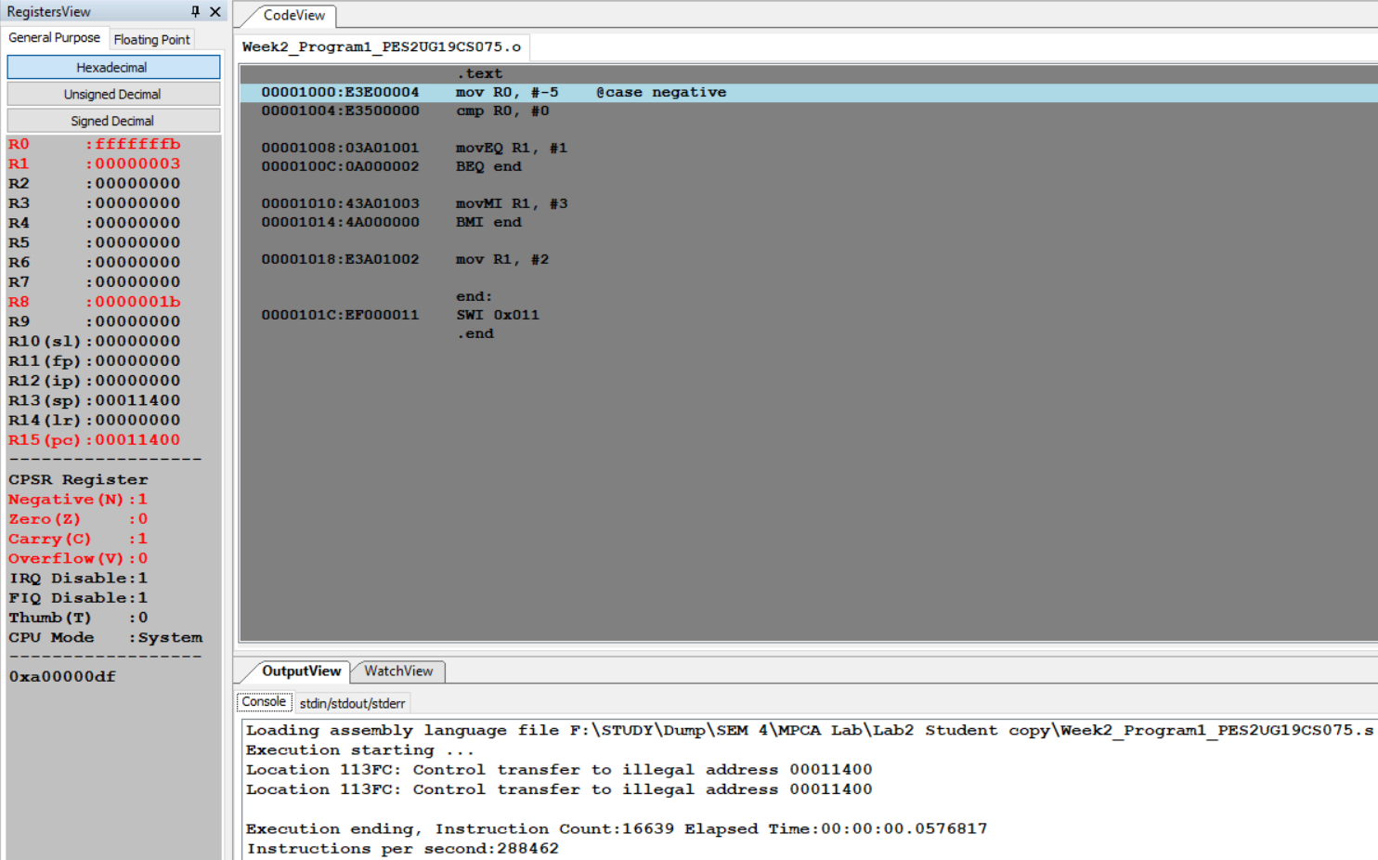

Program Number: 2

Write an ALP to compare the value of R0 and R1, add if R0 = R1, else subtract

1. ARM Assembly Code for each program

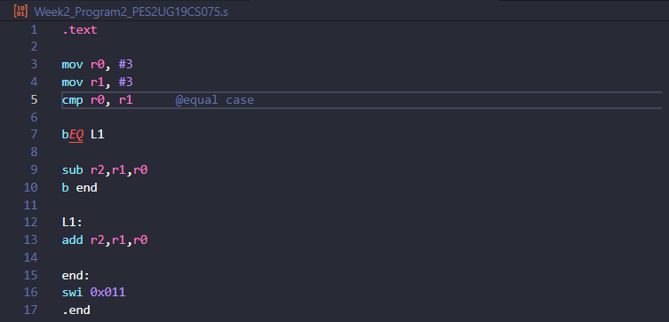

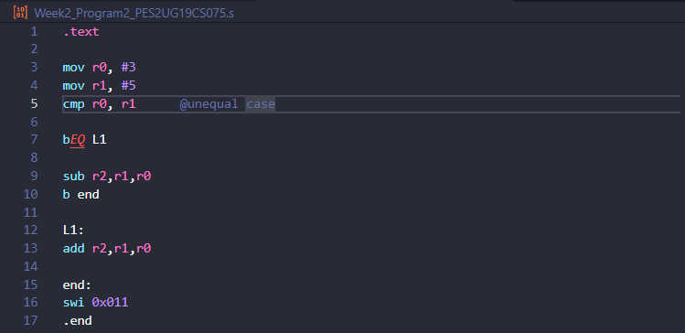

1. Output Screen Shot

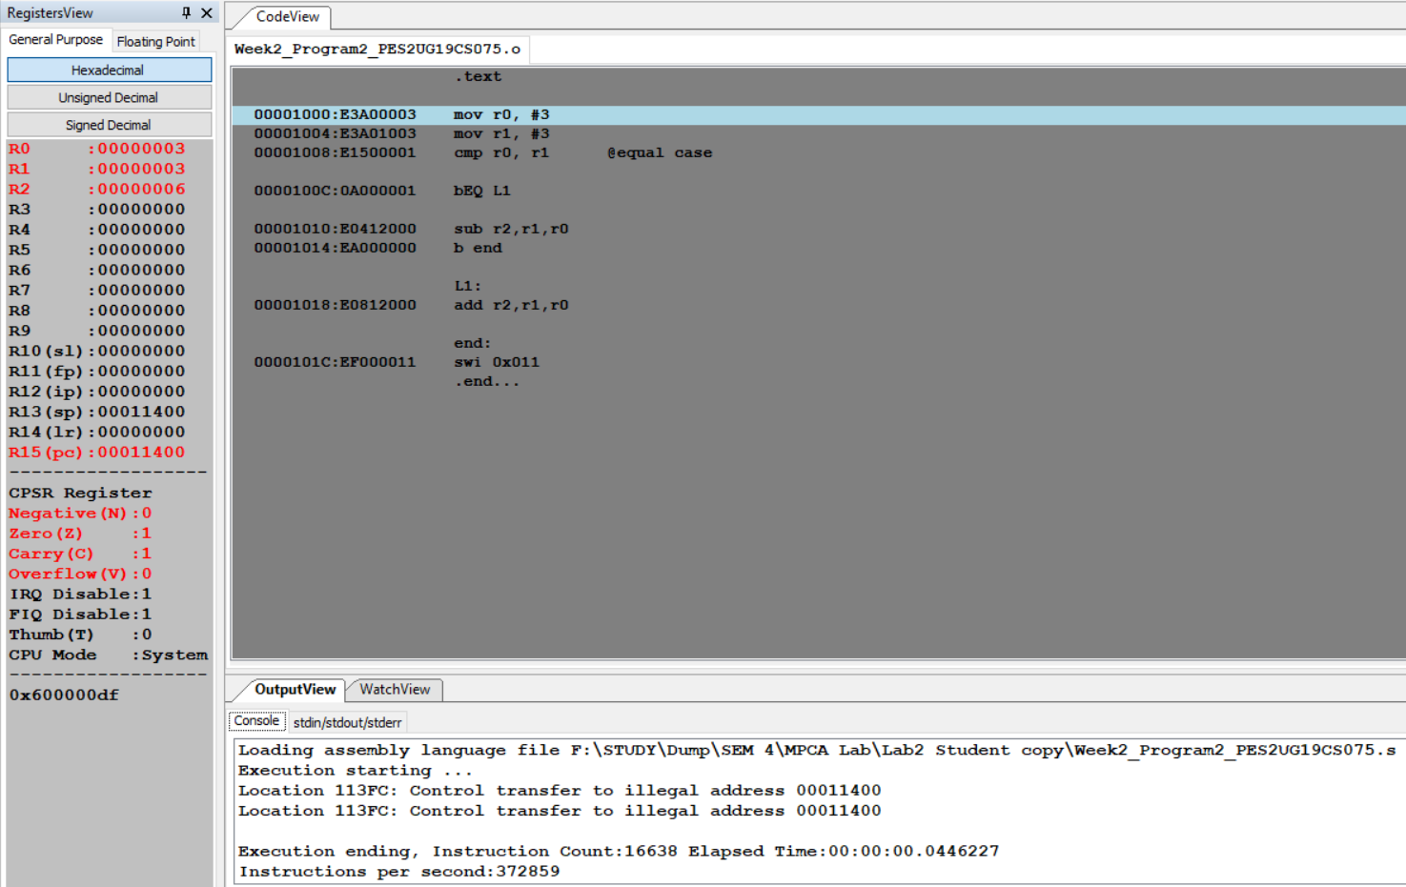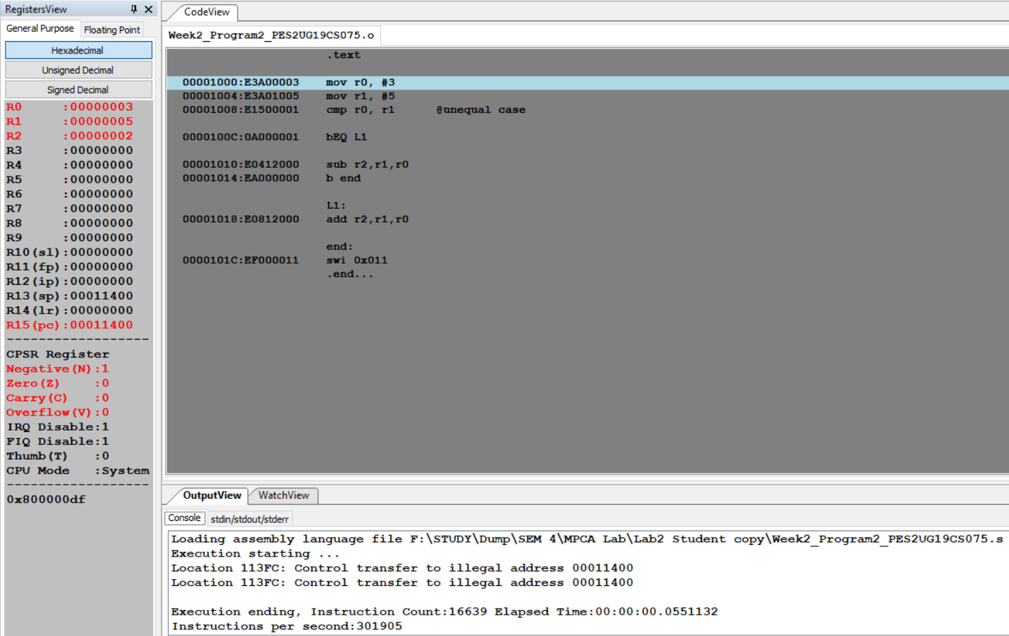

Program Number: 3

Write an ALP to find the factorial of a number stored in R0. Store the value in R1 (without using LDR and STR instructions). Use only registers.

1. ARM Assembly Code for each program

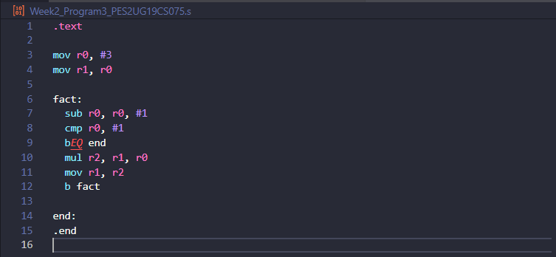

1. Output Screen Shot

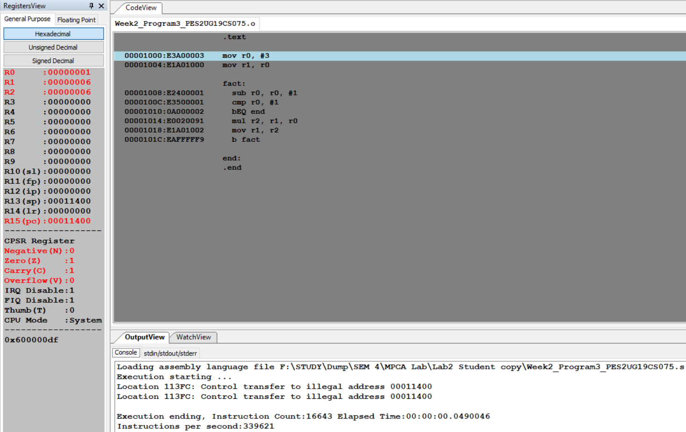

Program Number: 4a

Write an ALP to add two 32 bit numbers loaded from memory and store the result in memory.

1. ARM Assembly Code for each program 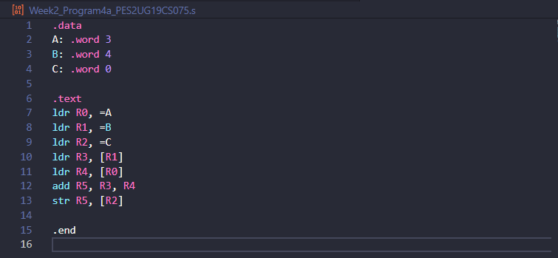
2. Output Screen Shot 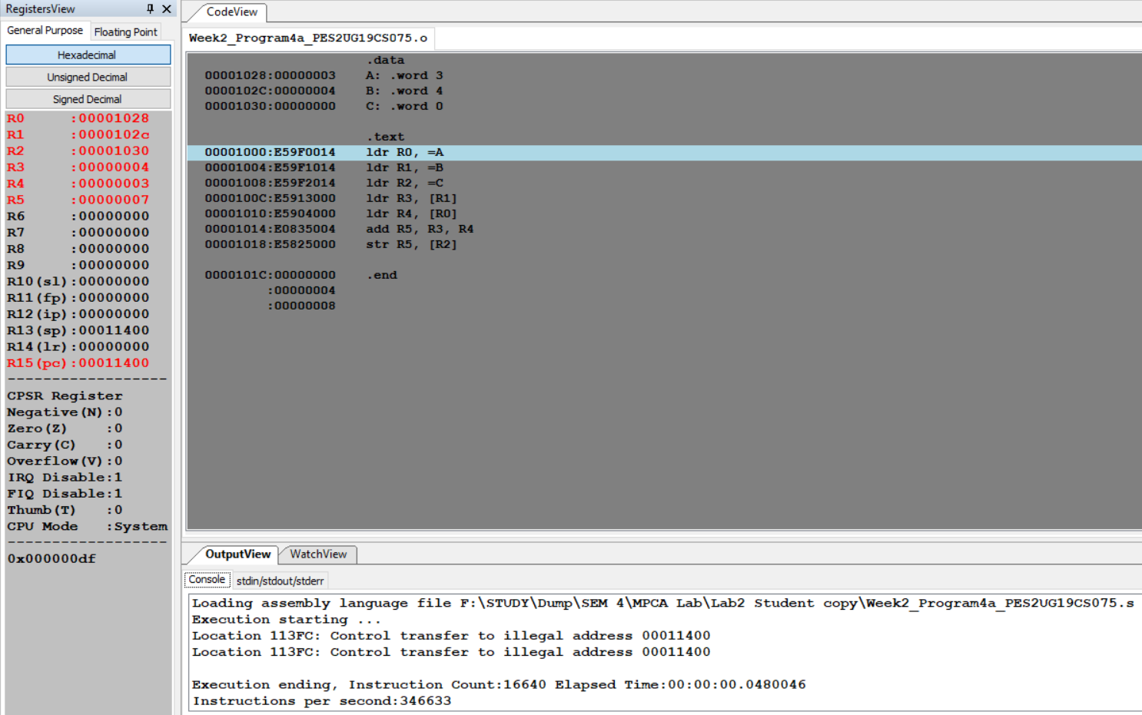

Program Number: 4b

Write an ALP to add two 16 bit numbers loaded from memory and store the result in memory.

1. ARM Assembly Code for each program 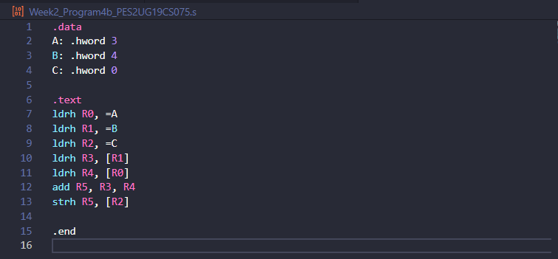
2. Output Screen Shot 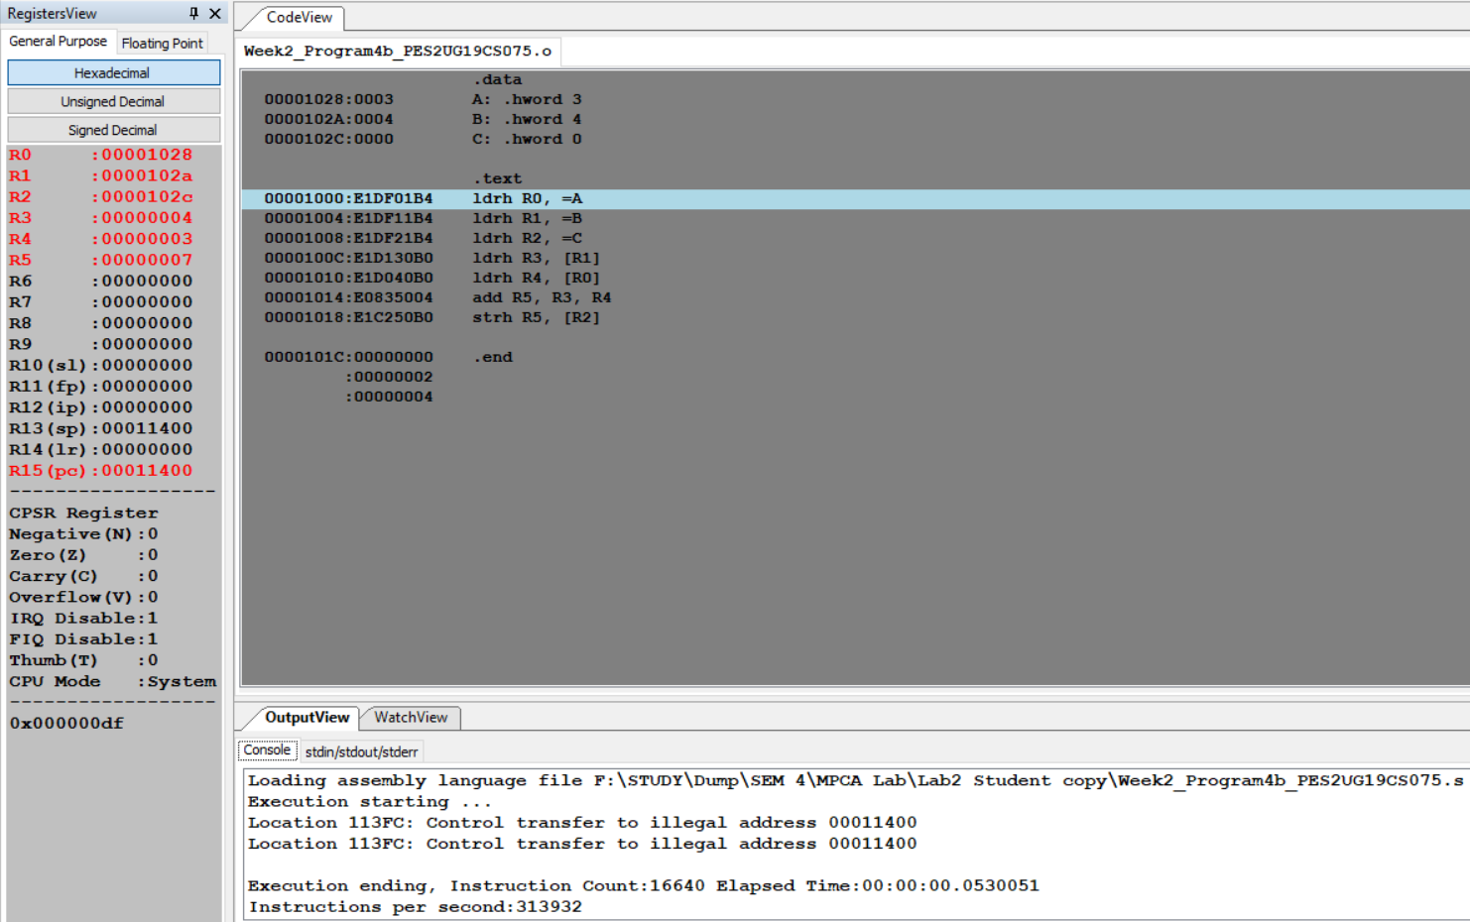

Program Number: 5a

Write an ALP to find GCD of two numbers (without using LDR and STR instructions). Both numbers are in registers. Use only registers.

1. ARM Assembly Code for each program 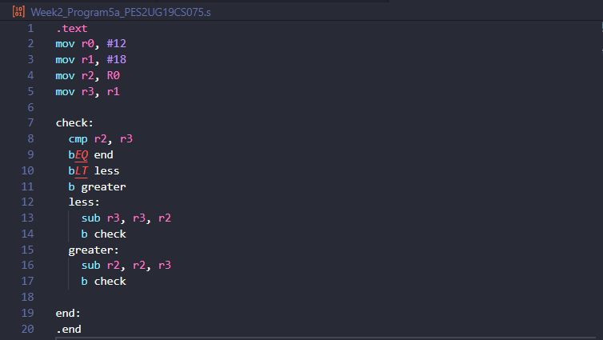
2. Output Screen Shot 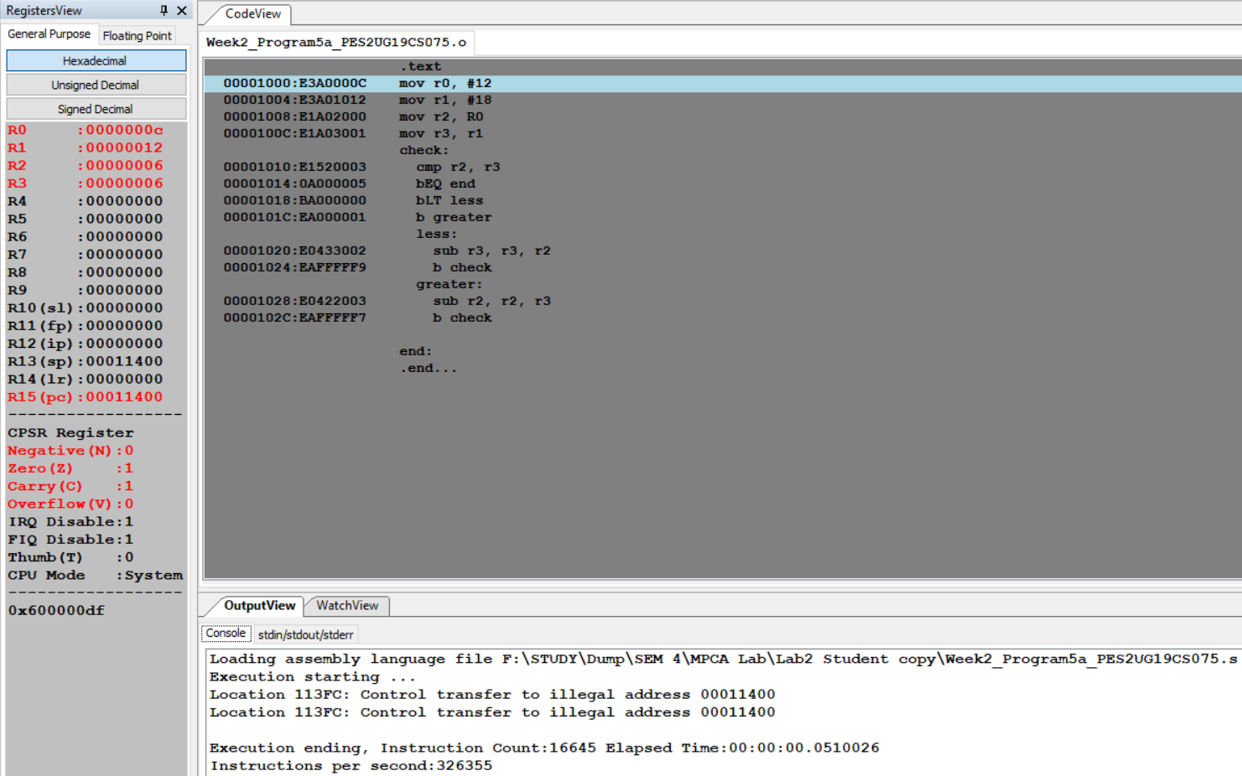

Program Number: 5b

Write an ALP to find the GCD of given numbers (both numbers in memory) Store result in memory.

1. ARM Assembly Code for each program 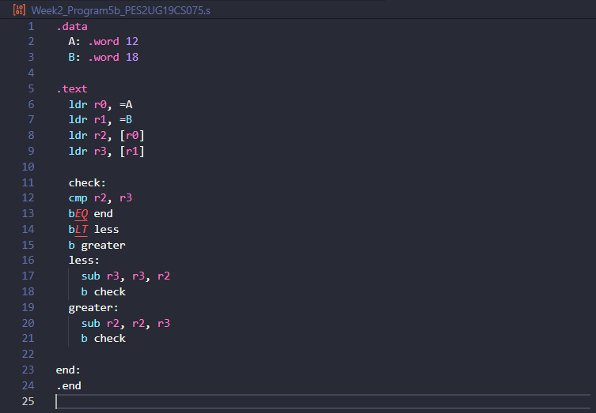
2. Output Screen Shot 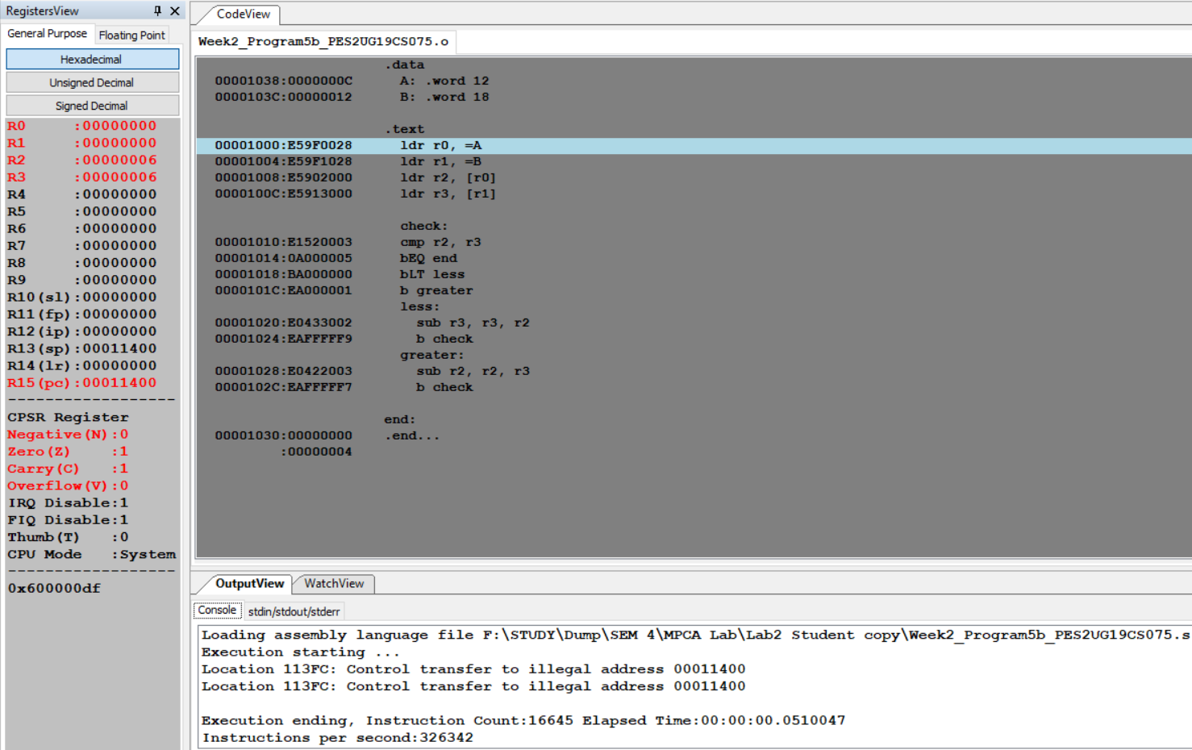

Program Number: 6a

Write an ALP to add an array of ten 32 bit numbers from memory.

1. ARM Assembly Code for each program 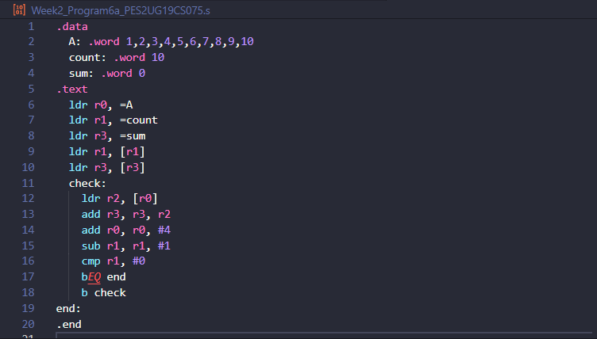
2. Output Screen Shot 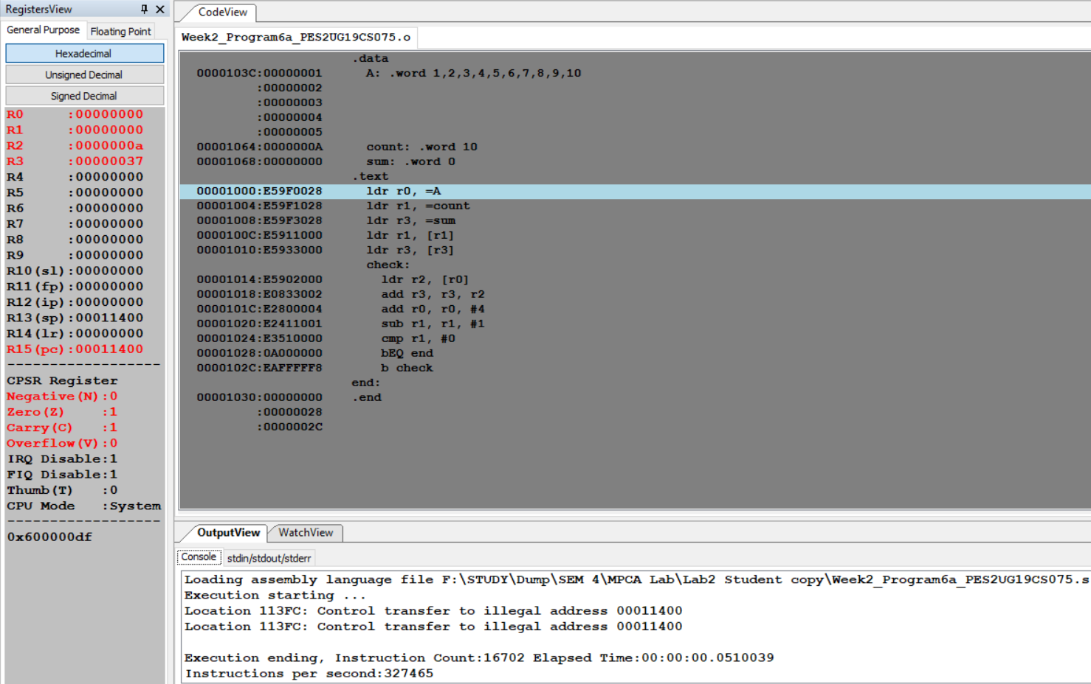

Program Number: 6b

Write an ALP to add array of ten 8 bit numbers taking data from memory location stored as byte data (use .byte to store the data instead of .word).

1. ARM Assembly Code for each program 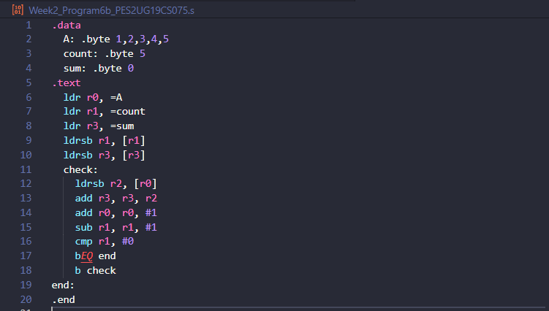
2. Output Screen Shot 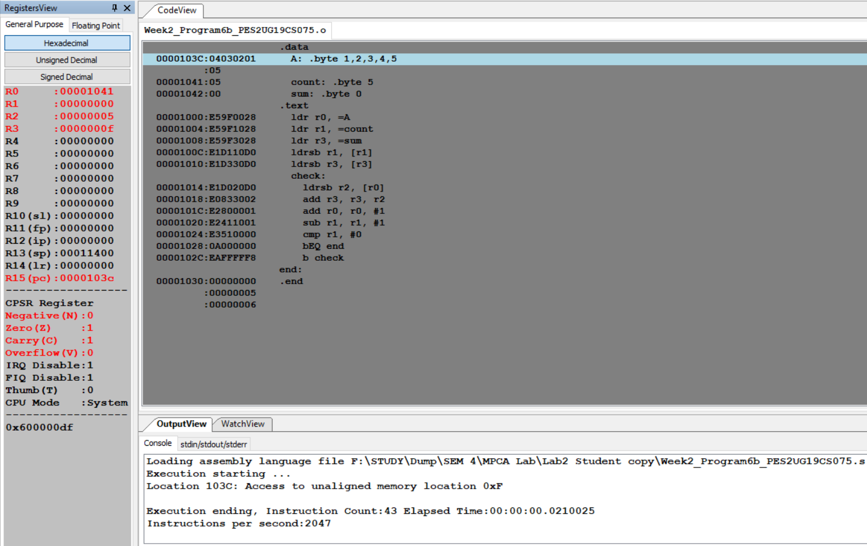

Program Number: 7

Write an ALP to multiply using barrel shifter.

35*R0

1. ARM Assembly Code for each program 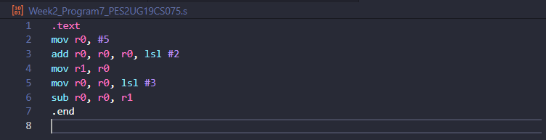
2. Output Screen Shot 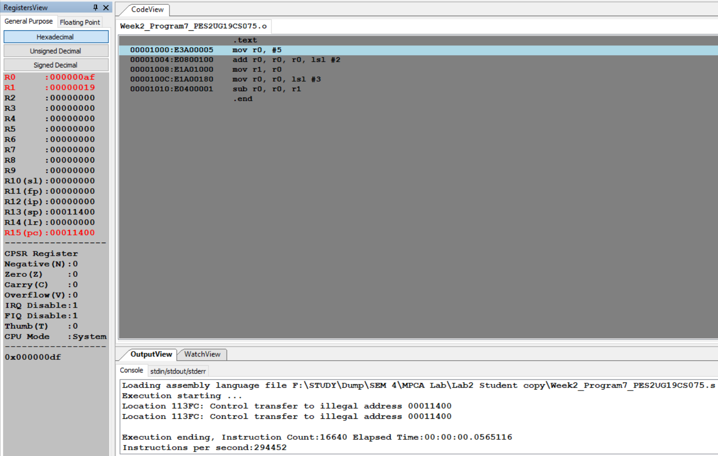

Program Number: 8

Write an ALP to evaluate the expression (A+B) + (3*B), where A and B are memory location.

* Use LSL instruction for multiplication.

1. ARM Assembly Code for each program 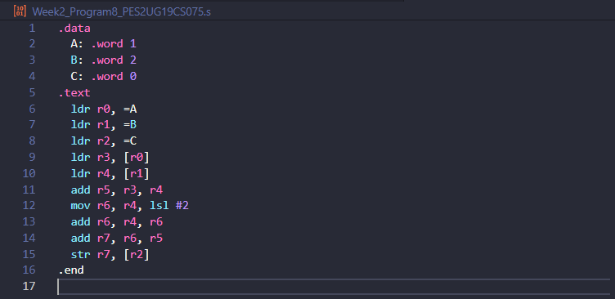
2. Output Screen Shot 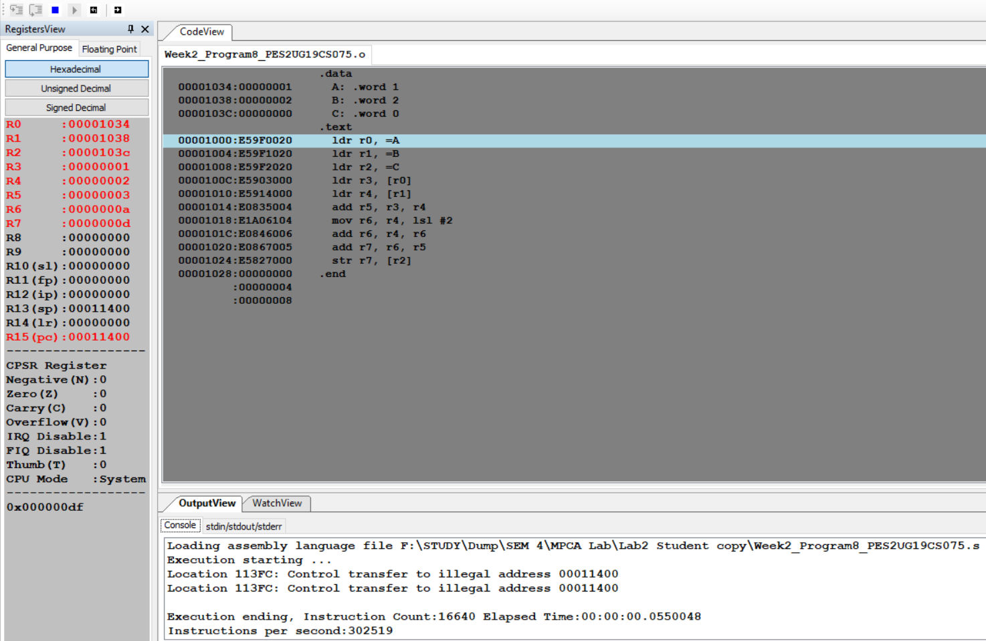

**Disclaimer:**

The programs and output submitted is duly written, verified, and executed by me.

I have not copied from any of my peers nor from the external resource such as internet.

If found plagiarized, I will abide with the disciplinary action of the University.

Signature: *Atul Anurag*

Name: Atul Anurag

SRN: PES2UG19CS075

Section: B

Date: 03-02-2021